apiculus® User Manual

Cloud Operations

IndiQus Technologies Pvt. Ltd.

**Table of Contents**

**About Cloud Operations** **4**

**Virtual Machines** **4**

Getting Started on a Flat/EC Network 4

Getting Started on a Tiered/VPC Network 5

Virtual Machine Operations 6

**Volumes** **9**

Purchasing a Disk Volume 10

Volume Operations 12

**Snapshots** **14**

Creating a Volume Snapshot 14

Snapshot Operations 15

**Templates** **17**

Creating a Template 17

Template Operations 17

**Virtual Private Clouds** **18**

Getting Started with a VPC 18

VPC Operations 19

VPC Component Operations 20

**VPN Gateways and Connections** **21**

Creating a VPN Gateway 21

**Using VPN Connections with VPC** **21**

Using Remote Access VPN with VPC 22

**Security Groups** **22**

**SSH Keys** **23**

Managing SSH Keys 23

Using Virtual Machines with SSH Keys 23

# 

# About Cloud Operations

apiculus CloudConsole gives you a holistic set of actions to carry out your day 1 and day 2 cloud operations. All your cloud resources can be accessed from the **apiculus Cloud** menu in the main navigation panel and all resources support an extensive range of operational actions.

# Virtual Machines

Virtual machine instances form the core of apiculus Cloud and can be accessed from the **apiculus Cloud > Virtual Machines** section on the main navigation panel.

To start using virtual machines, you need to first purchase a virtual machine or compute subscription from the apiculus Cloud Marketplace. You can do so by navigating to the **Marketplace > Compute and Storage** section on the main navigation panel.

Before purchasing a virtual machine, it is important to plan the architecture, networking and access to the virtual machine. As a thumb rule:

* You can use a ‘flat’ network (or EC, elastic compute) virtual machine to get started quickly and set up your virtual machine behind apiculus Cloud’s global server load balancer (GSLB) and control access by setting up virtual firewall rules; or;
* You can use a ‘tiered’ network (or VPC, virtual private cloud) virtual machine to configure advanced networking and application architectures and control access by setting up access control lists.

## Getting Started on a Flat/EC Network

To get started on a flat network, follow the steps:

1. Navigate to **Marketplace** > **Compute and Storage**.
2. From the **Zone** dropdown on top, choose a flat network zone. *Typically, this will be marked as an EC zone.*
3. Choose the desired configurations for **operating system**, **vCPU**, **RAM** and **root disk**.
4. From the available options shown on the panel on the right-hand side, choose the plan that suits your virtual machine requirements. *Please note that some configurations might not have hourly plans. This is absolutely normal.*
5. Alternatively, you can also navigate to **apiculus Cloud** > **Virtual Machines**, select the appropriate **region** and **zone** from the dropdown menu on top, and click on the **Buy More** button. This will show you a list of all available virtual machine configurations along with their prices.

Once you’ve chosen the desired plan, you’ll be asked for the following details to create the virtual machine:

* **Name** of the virtual machine.
* The security group to use for this virtual machine. *There will always be a default security group in all accounts.*
* Option to use **SSH keys** with the virtual machine. *This option can be accessed later.*
* If there are **promo/discount codes** available for this purchase, you’ll be shown those options.
* An option to receive the machine’s **password on email**. *This option can be accessed later.*

Clicking on **Confirm Purchase** with the above information will provision the virtual machine inside the chosen EC zone in your account.

Please note that this might take up to 5-8 minutes. You may use the CloudConsole during this time, but it is advised that you do not refresh the browser window.

Once ready, you’ll be notified of this purchase on your email address on record. The newly created virtual machine can be accessed from **apiculus Cloud > Virtual Machines** on the main navigation panel.

## Getting Started on a Tiered/VPC Network

To get started on a tiered network, follow the steps:

1. Navigate to **Marketplace** > **Compute and Storage**.
2. From the **Zone** dropdown on top, choose a tiered network zone. *Typically, this will be marked as a VPC zone.*
3. Choose the desired configurations for **operating system**, **vCPU**, **RAM** and **root disk**.
4. From the available options shown on the panel on the right-hand side, choose the plan that suits your virtual machine requirements. *Please note that some configurations might not have hourly plans. This is absolutely normal.*
5. Alternatively, you can also navigate to **apiculus Cloud** > **Virtual Machines**, select the appropriate **region** and **zone** from the dropdown menu on top, and click on the **Buy More** button. This will show you a list of all available virtual machine configurations along with their prices.

Once you’ve chosen the desired plan, you’ll be asked for the following details to create the virtual machine:

* **Name** of the virtual machine.
* The **VPC** or **network** for this machine to be a part of. *Please note that to add a virtual machine to a VPC, you need to have a VPC configured with at least one tier.*
* The **tier** or **subnet** for this machine to be in.
* Option to use **SSH keys** with the virtual machine. *This option can be accessed later.*
* If there are **promo/discount codes** available for this purchase, you’ll be shown those options.
* An option to receive the machine’s **password on email**. *This option can be accessed later.*

Clicking on **Confirm Purchase** with the above information will provision the virtual machine inside the chosen VPC in your account.

Please note that this might take up to 5-8 minutes. You may use the CloudConsole during this time, but it is advised that you do not refresh the browser window.

Once ready, you’ll be notified of this purchase on your email address on record. The newly created virtual machine can be accessed from **apiculus Cloud > Virtual Machines** on the main navigation panel.

## Virtual Machine Operations

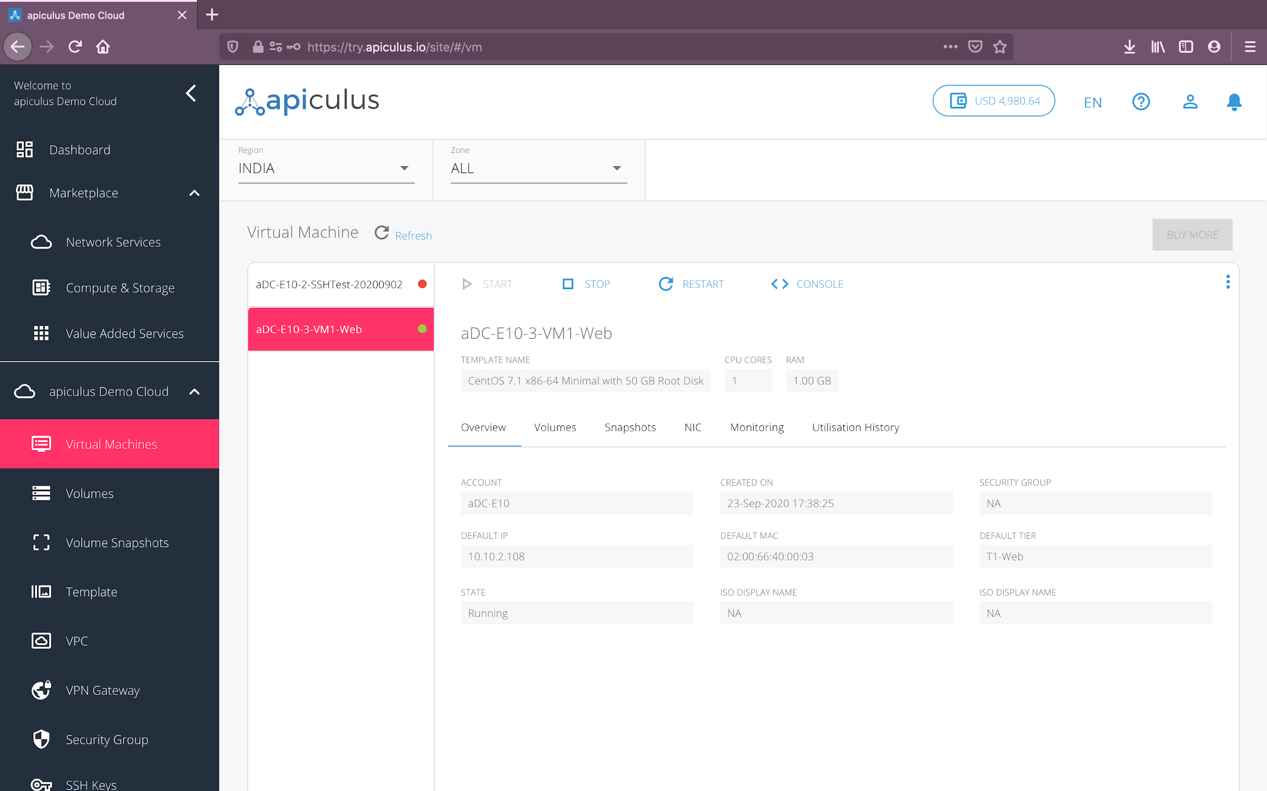

apiculus Cloud allows a host of operations on virtual machines. These can be classified as informational, quick and advanced actions:

1. **Informational:** All the information relating to the virtual machine is available and can be accessed by navigating to **apiculus Cloud > Virtual Machines** on the main navigation panel, and clicking on the desired virtual machine from the list of virtual machines.
   1. **Overview:** shows information about the virtual machine, e.g., its IP address, creation date, internal ID etc.
   2. **Volumes:** shows all the volumes (root and addon) attached to the virtual machine.
   3. **Snapshots:** shows all virtual machine snapshots, which can be used to revert the virtual machine to an earlier state.
   4. **NIC:** shows all NIC for virtual machines shared across multiple VPC and tiers.
   5. **Monitoring:** shows a 24-hour time-scale graph with a 30-day trend line for the following parameters:
      1. CPU utilisation
      2. RAM utilisation
      3. Disk utilisation
      4. 1-min load average
      5. 5-min load average
      6. 15-min load average
   6. **Utilisation History:** shows a historical date-wise table for daily maximum, minimum and average readings for all parameters.
2. **Quick Actions:** You can perform quick one-click actions on all virtual machines. These are the most common actions that are taken on virtual machines and can be accessed from a ‘quick action toolbar’ on top of each virtual machine’s details.
   1. **Start:** to start a stopped virtual machine.
   2. **Stop:** to stop a running virtual machine.
   3. **Restart:** to restart a running virtual machine.
   4. **Console:** to view a virtual machine’s console. *Please note that console should be viewed only for diagnostics and should always be logged out of. For regular virtual machine access, it is advisable to use a terminal.*
3. **Advanced Actions:** Advanced actions may not be one-click and may be conditional to the virtual machine’s state, its zone, the underlying hypervisor, its operating system or any other parameter. These options can be accessed by clicking on the three-dot ellipsis menu to the extreme right of the quick action toolbar.
   1. **Manage Autoscale:** this will navigate to the autoscale console for creating autoscale rules. *Please note that autoscale is only available for virtual machines created as part of a VPC.*
   2. **Force Stop:** to forcefully stop a running or a hung virtual machine.
   3. **Take Snapshot:** to take a virtual machine snapshot. *Please note that some hypervisors may not allow snapshots on running virtual machines. If this action fails, please stop the virtual machine and try again.*
   4. **Change Configuration:** to manually upgrade or downgrade a virtual machine (i.e., vertical scaling). *Please note that due to operating system and hypervisor compatibility, we have disabled vertical scaling on running virtual machines.*
   5. **Add NIC:** to share a virtual machine across multiple VPC or tiers.
   6. **Reset Password:** to reset the virtual machine’s root user password.
   7. **Reset SSH Key:** to (re)set the virtual machine’s SSH key association.
   8. **Rename:** to rename the virtual machine.
   9. **Delete:** to delete the virtual machine. *Please note that deleting a virtual machine will remove it entirely along with its subscription and is a non-reversible action.*

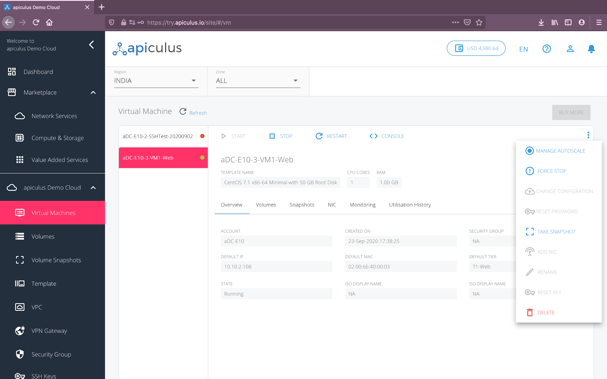

# 

# Volumes

Volumes are disk partitions that are used with virtual machines. Volumes on apiculus Cloud are of two types:

1. **Root Disks:** These are the root partition disks that come bundled with a virtual machine. These can not be removed from a virtual machine.
2. **Addon Disks:** These are additional disk partitions that can be purchased and attached to (or detached from) virtual machines.

All volumes can be accessed from the **apiculus Cloud > Volumes** section on the main navigation panel.

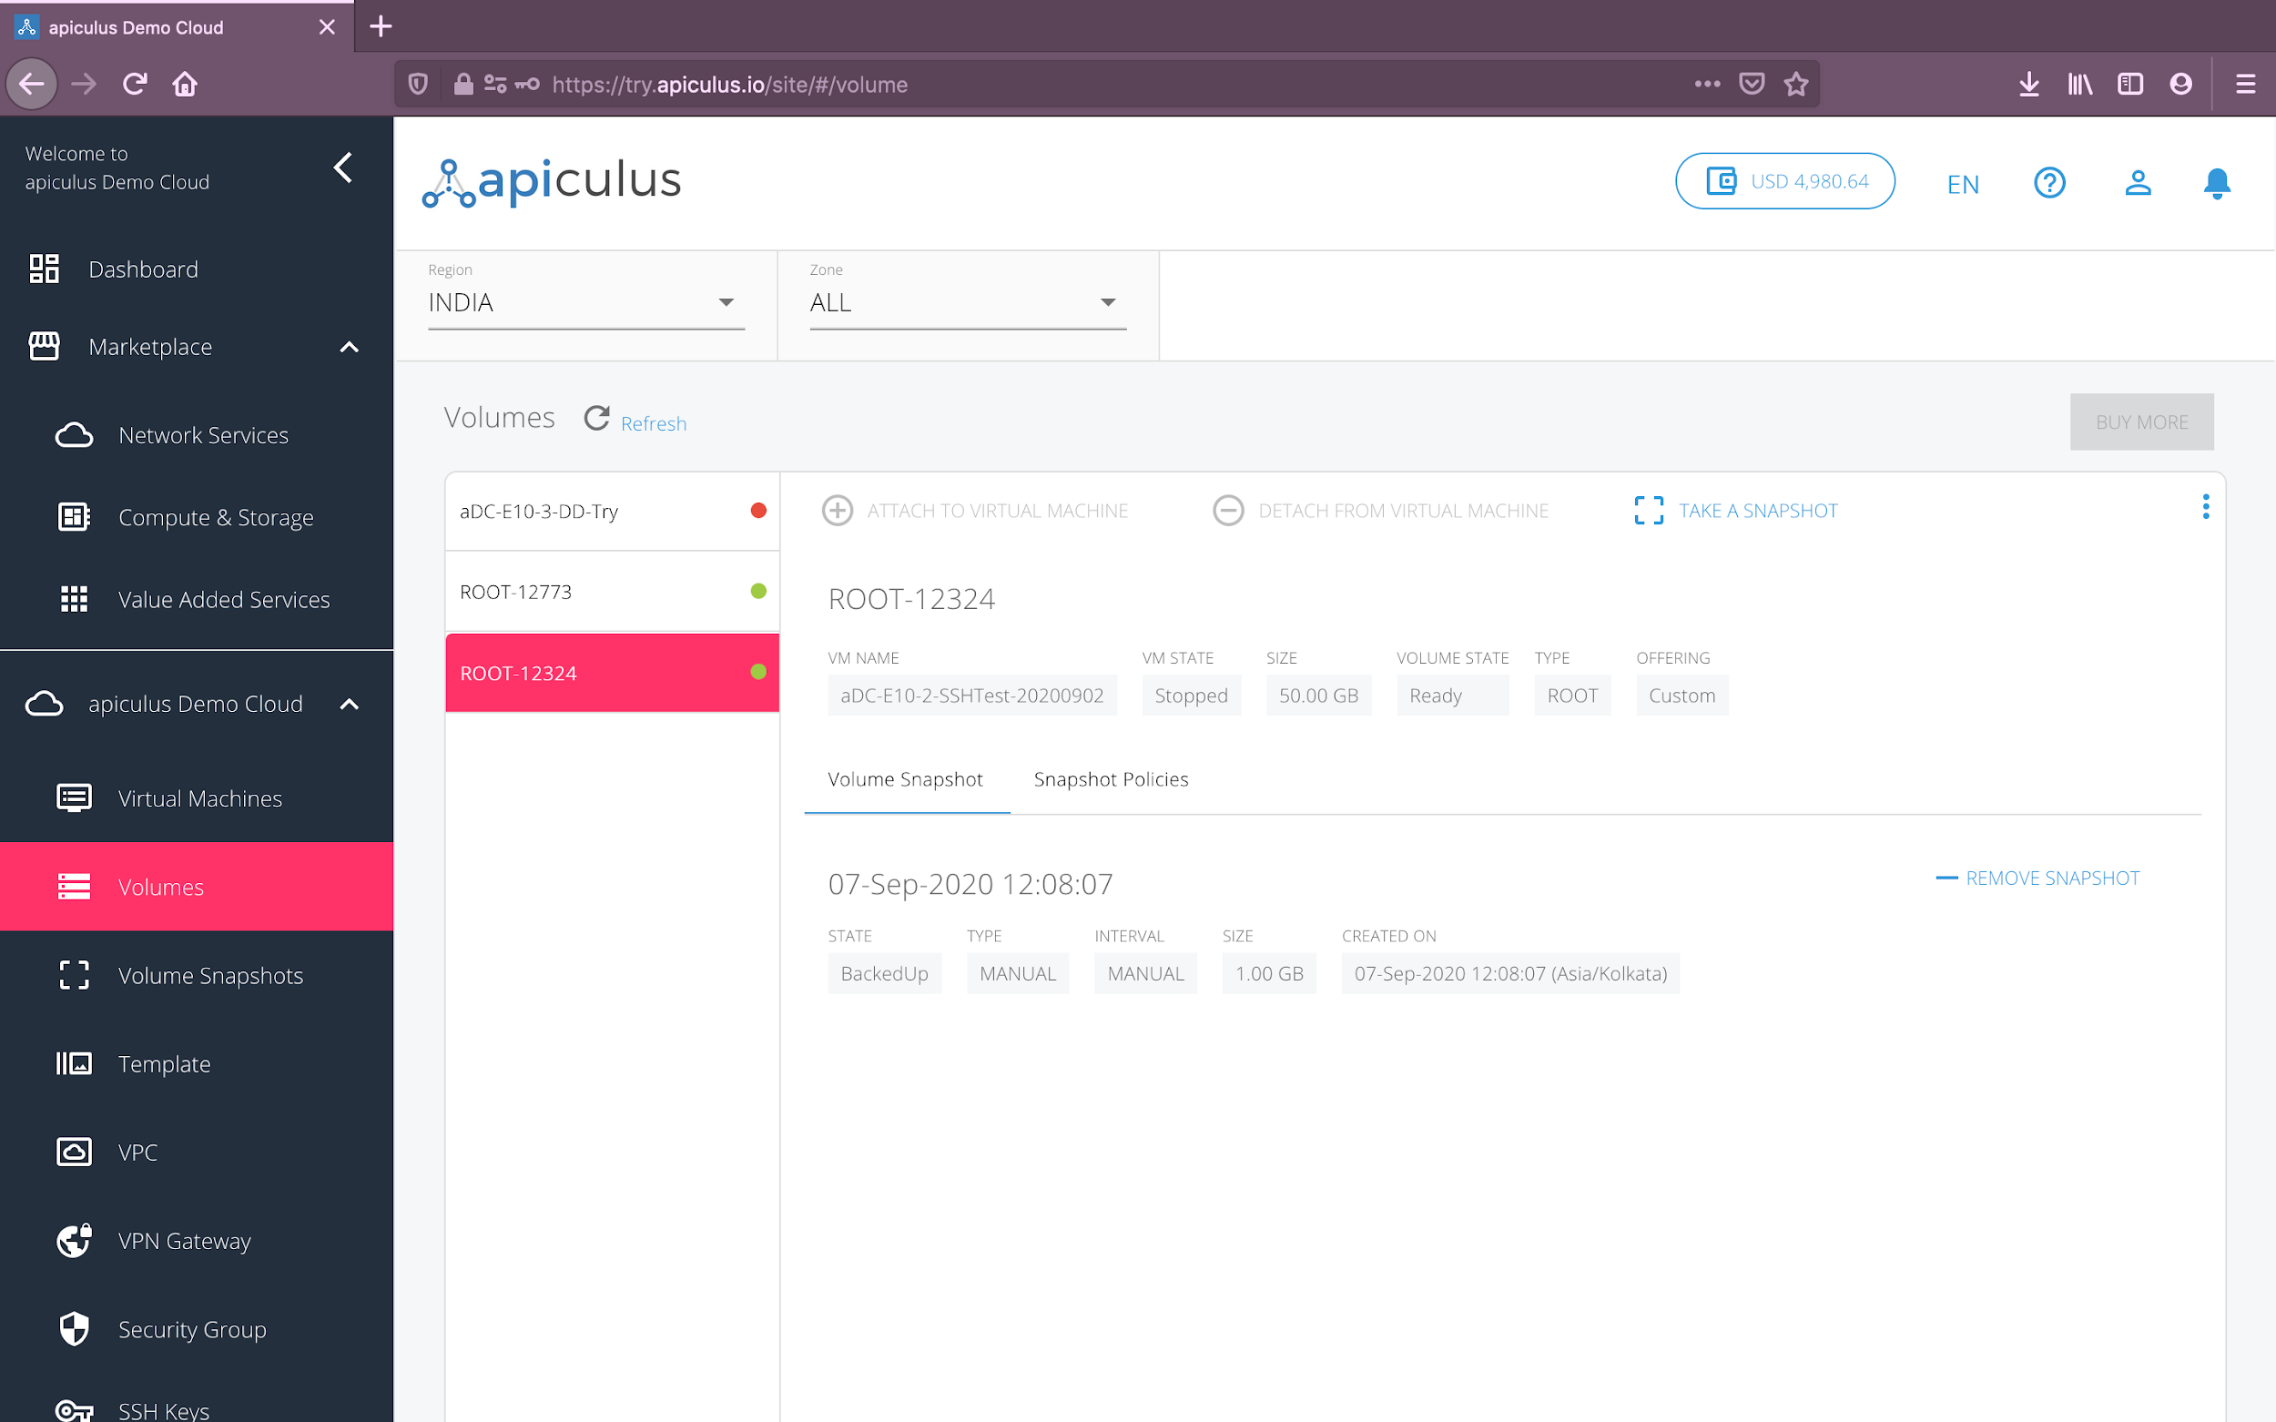

## 

## Purchasing a Disk Volume

Like virtual machines, disks are also zone/network-specific, i.e., an EC disk can not be used with a virtual machine in a VPC, and vice versa. While root disks are bundled with the virtual machine purchase (multiple options might be available), addon disks need to be purchased separately.

To purchase an addon disk, follow these steps:

1. Navigate to **Marketplace** > **Compute and Storage**.
2. From the **Zone** dropdown on top, choose the appropriate network zone.
3. Switch the category dropdown next to the section title from Virtual Machines to **Disk Volumes**.
4. Choose the required disk option.
5. From the available options shown on the panel on the right-hand side, choose the plan that suits your disk requirements. *Please note that some configurations might not have hourly plans. This is absolutely normal.*
6. Alternatively, you can also navigate to **apiculus Cloud** > **Volumes**, select the appropriate **region** and **zone** from the dropdown menu on top, and click on the **Buy More** button. This will show you a list of all available disk configurations along with their prices.

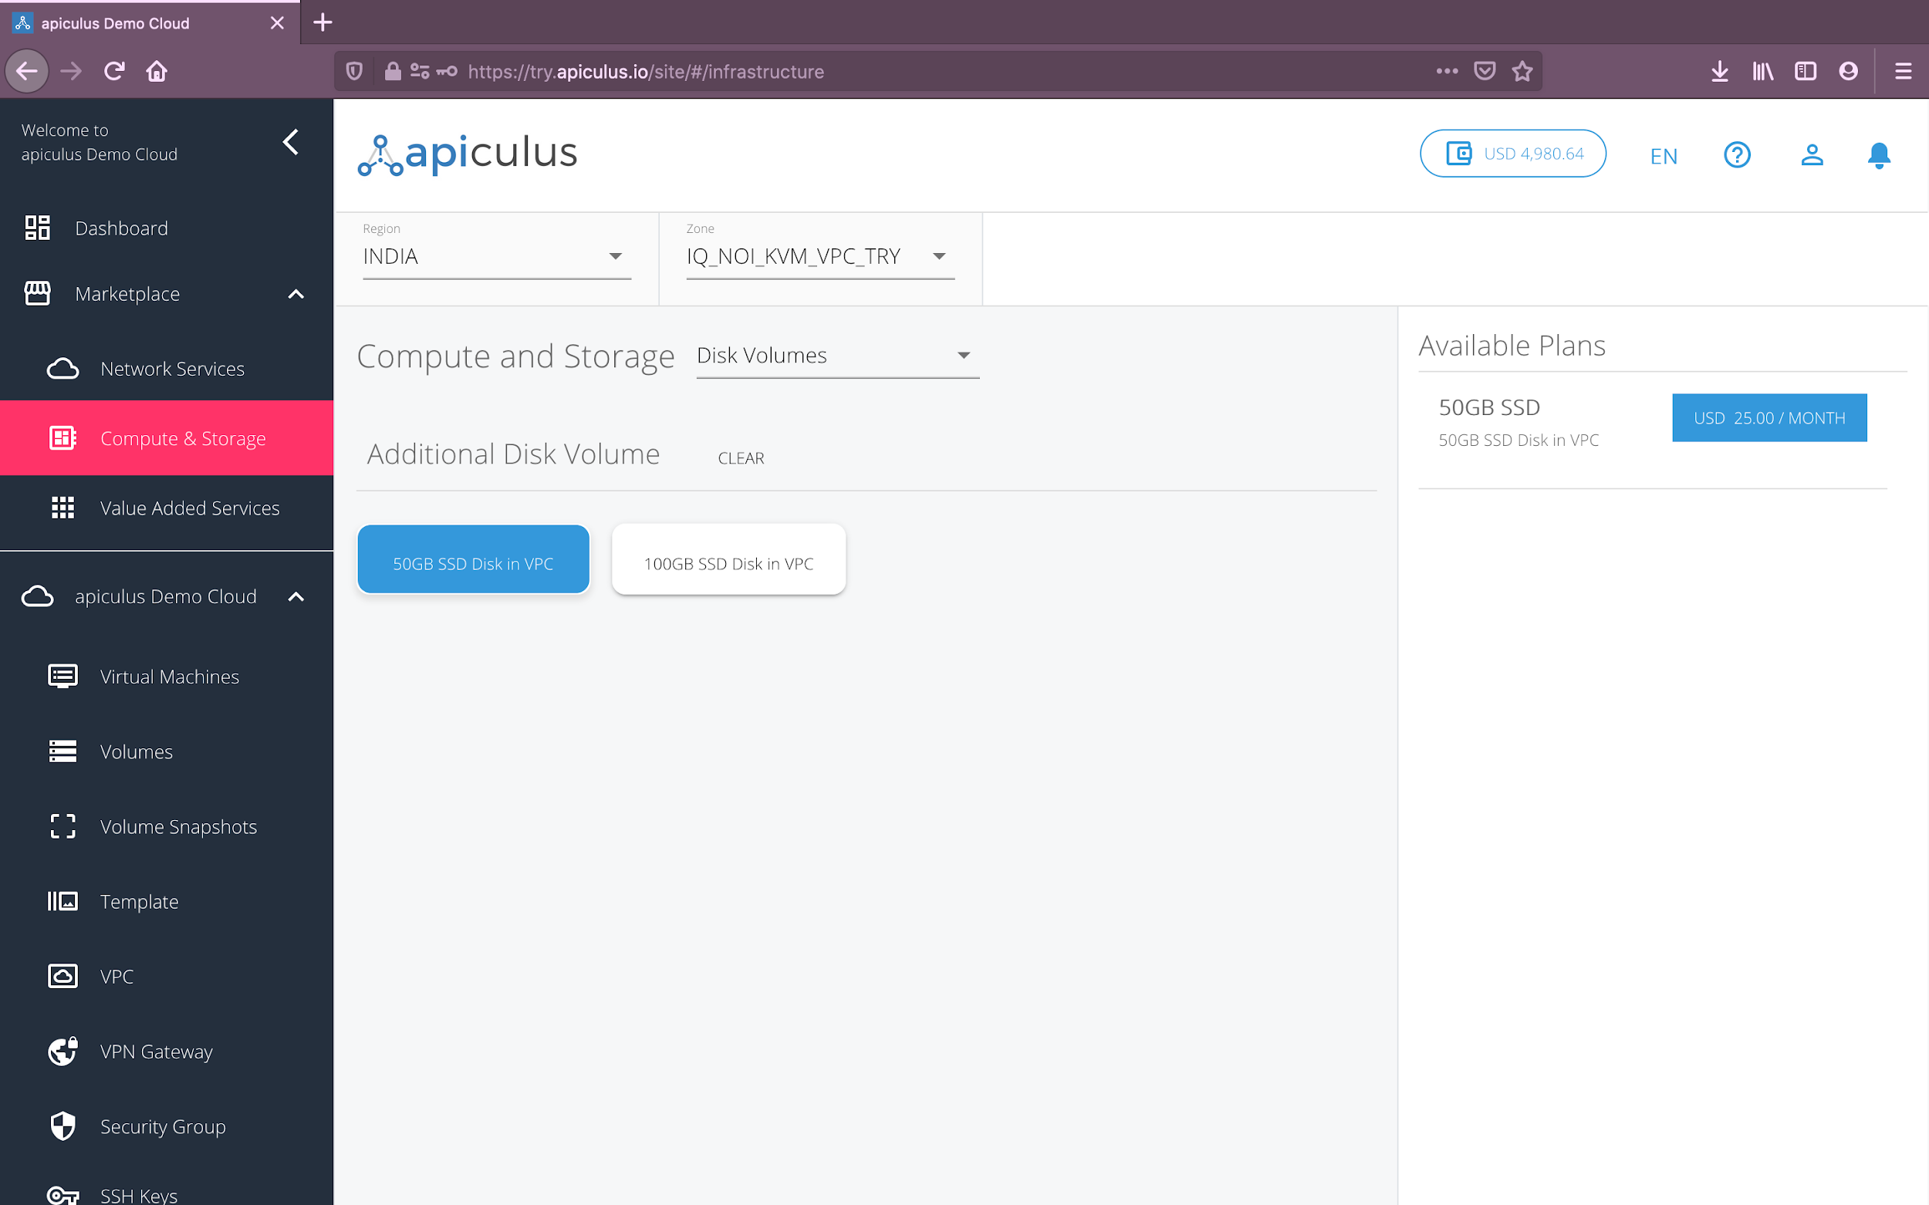

Once you’ve chosen the desired plan, you’ll be asked for the following details to create the volume:

* **Name** of the volume.
* If there are **promo/discount codes** available for this purchase, you’ll be shown those options.

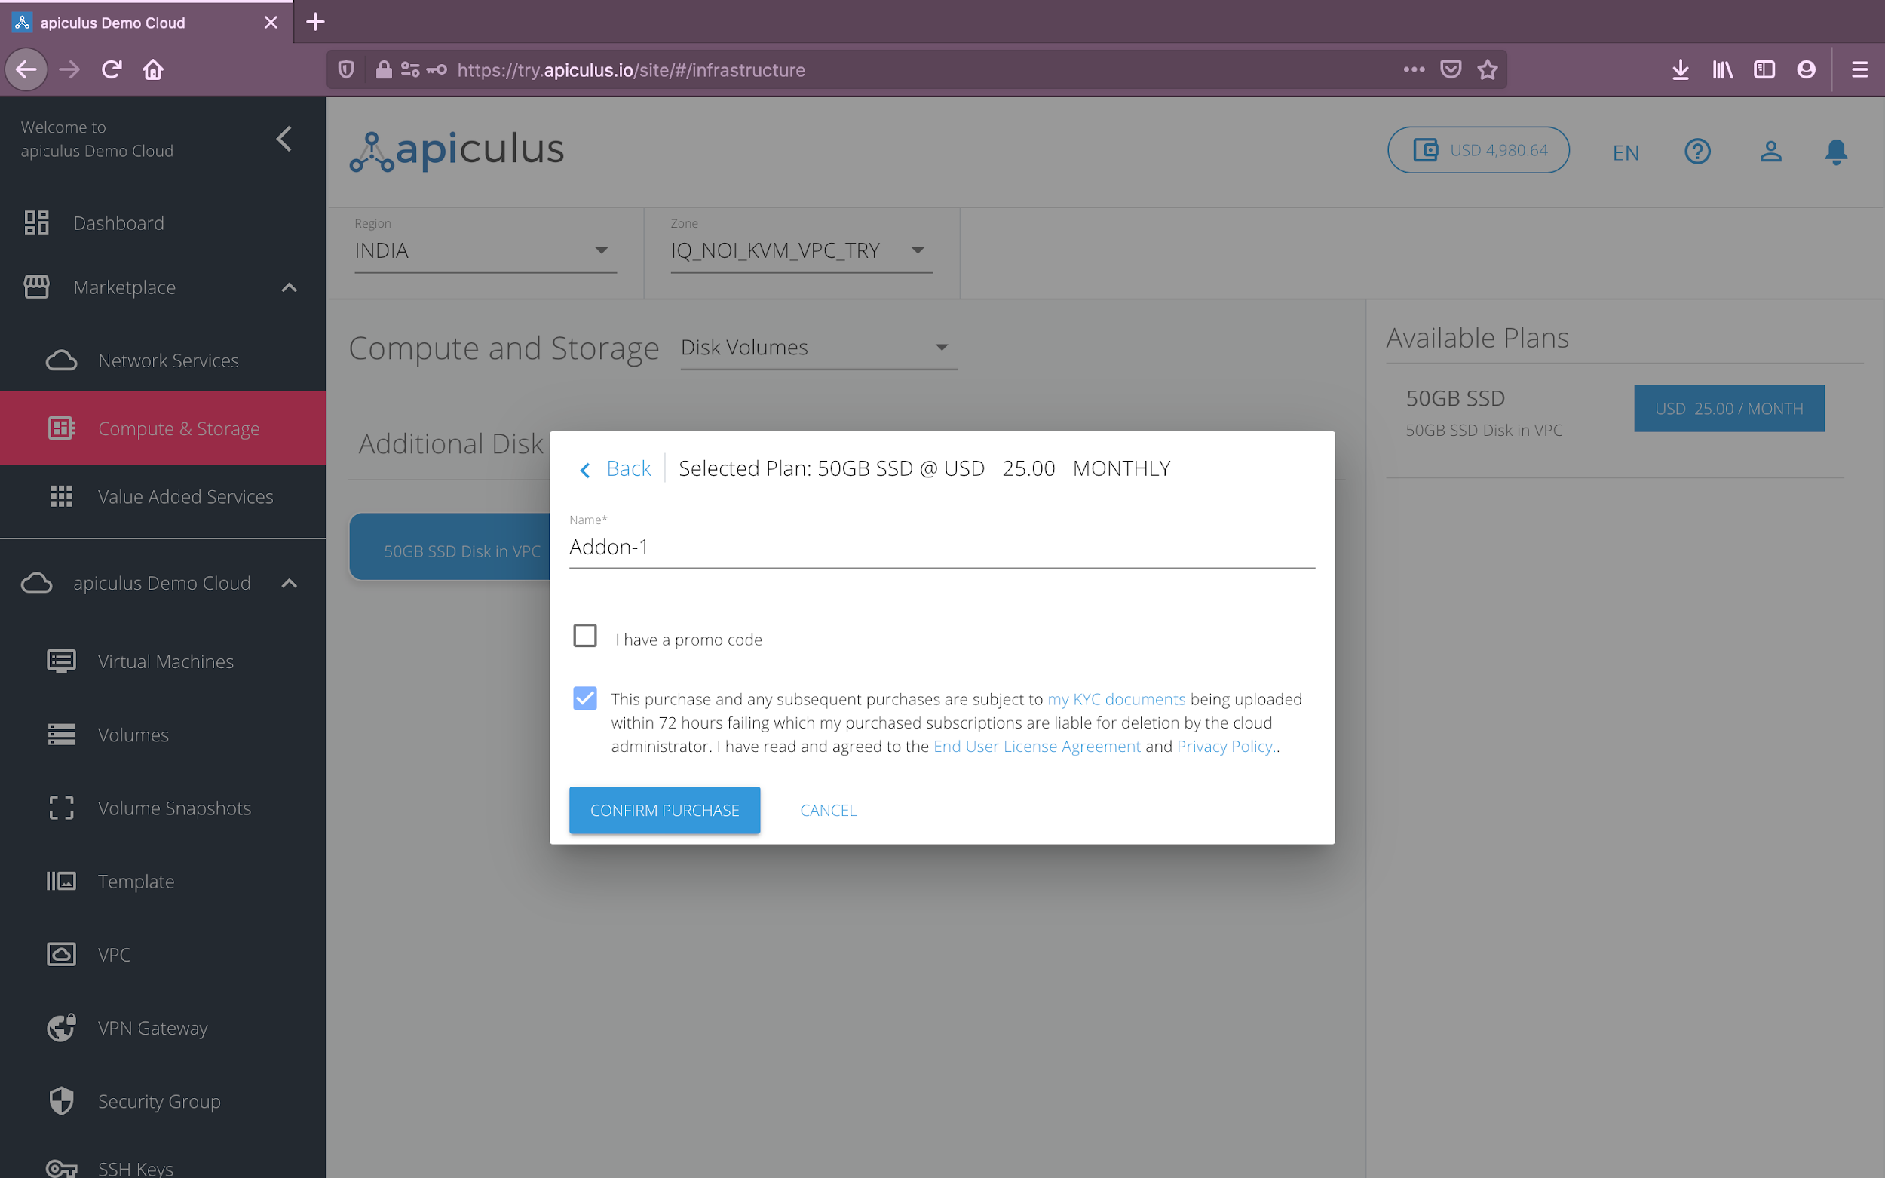

Clicking on **Confirm Purchase** with the above information will create the volume inside the chosen network in your account. *Please note that addon volumes are not attached to any virtual machine by default.*

Please note that this might take up to 5-8 minutes. You may use the CloudConsole during this time, but it is advised that you do not refresh the browser window.

Once ready, you’ll be notified of this purchase on your email address on record. The newly created volume can be accessed from **apiculus Cloud > Volumes** on the main navigation panel.

## 

## Volume Operations

apiculus Cloud allows a host of operations on volumes. These can be classified as informational, quick and advanced actions:

1. **Informational:** All the information relating to the volume is available and can be accessed by navigating to **apiculus Cloud > Volumes** on the main navigation panel, and clicking on the desired volume from the list of volumes. *Please note that root disks have the label ROOT in their names, while addon disks will show with the name defined during volume creation.*
   1. **Overview:** shows information about the volume, e.g., its size, mounting status, attached virtual machine etc.
   2. **Volume Snapshots:** shows all snapshots for this volume.
   3. **Snapshot Policies:** shows all snapshot schedules and policies configured for this volume.
2. **Quick Actions:** You can perform quick actions on all volumes. These are the most common actions that are taken on volumes and can be accessed from a ‘quick action toolbar’ on top of each volume’s details.
   1. **Attach to Virtual Machine:** to attach a volume to a virtual machine. *This option is not available for root disks.*
   2. **Detach from Virtual Machine:** to detach a volume from a virtual machine. *This option is not available for root disks.*
   3. **Take Snapshot:** to take a volume snapshot:
      1. **Instant Snapshot:** this creates a point-in-time snapshot of the volume.
      2. **Scheduled Snapshot:** this creates a snapshot policy based on:
         1. Frequency: hourly, daily, weekly or monthly.
         2. Time/Date: minutes past the hour, time of day, day of week and time of day, day of month and time of day, based on the chosen frequency.
         3. Timezone
         4. Snapshots to Keep: retention policy followed in a first-in-first-out (FIFO) model.

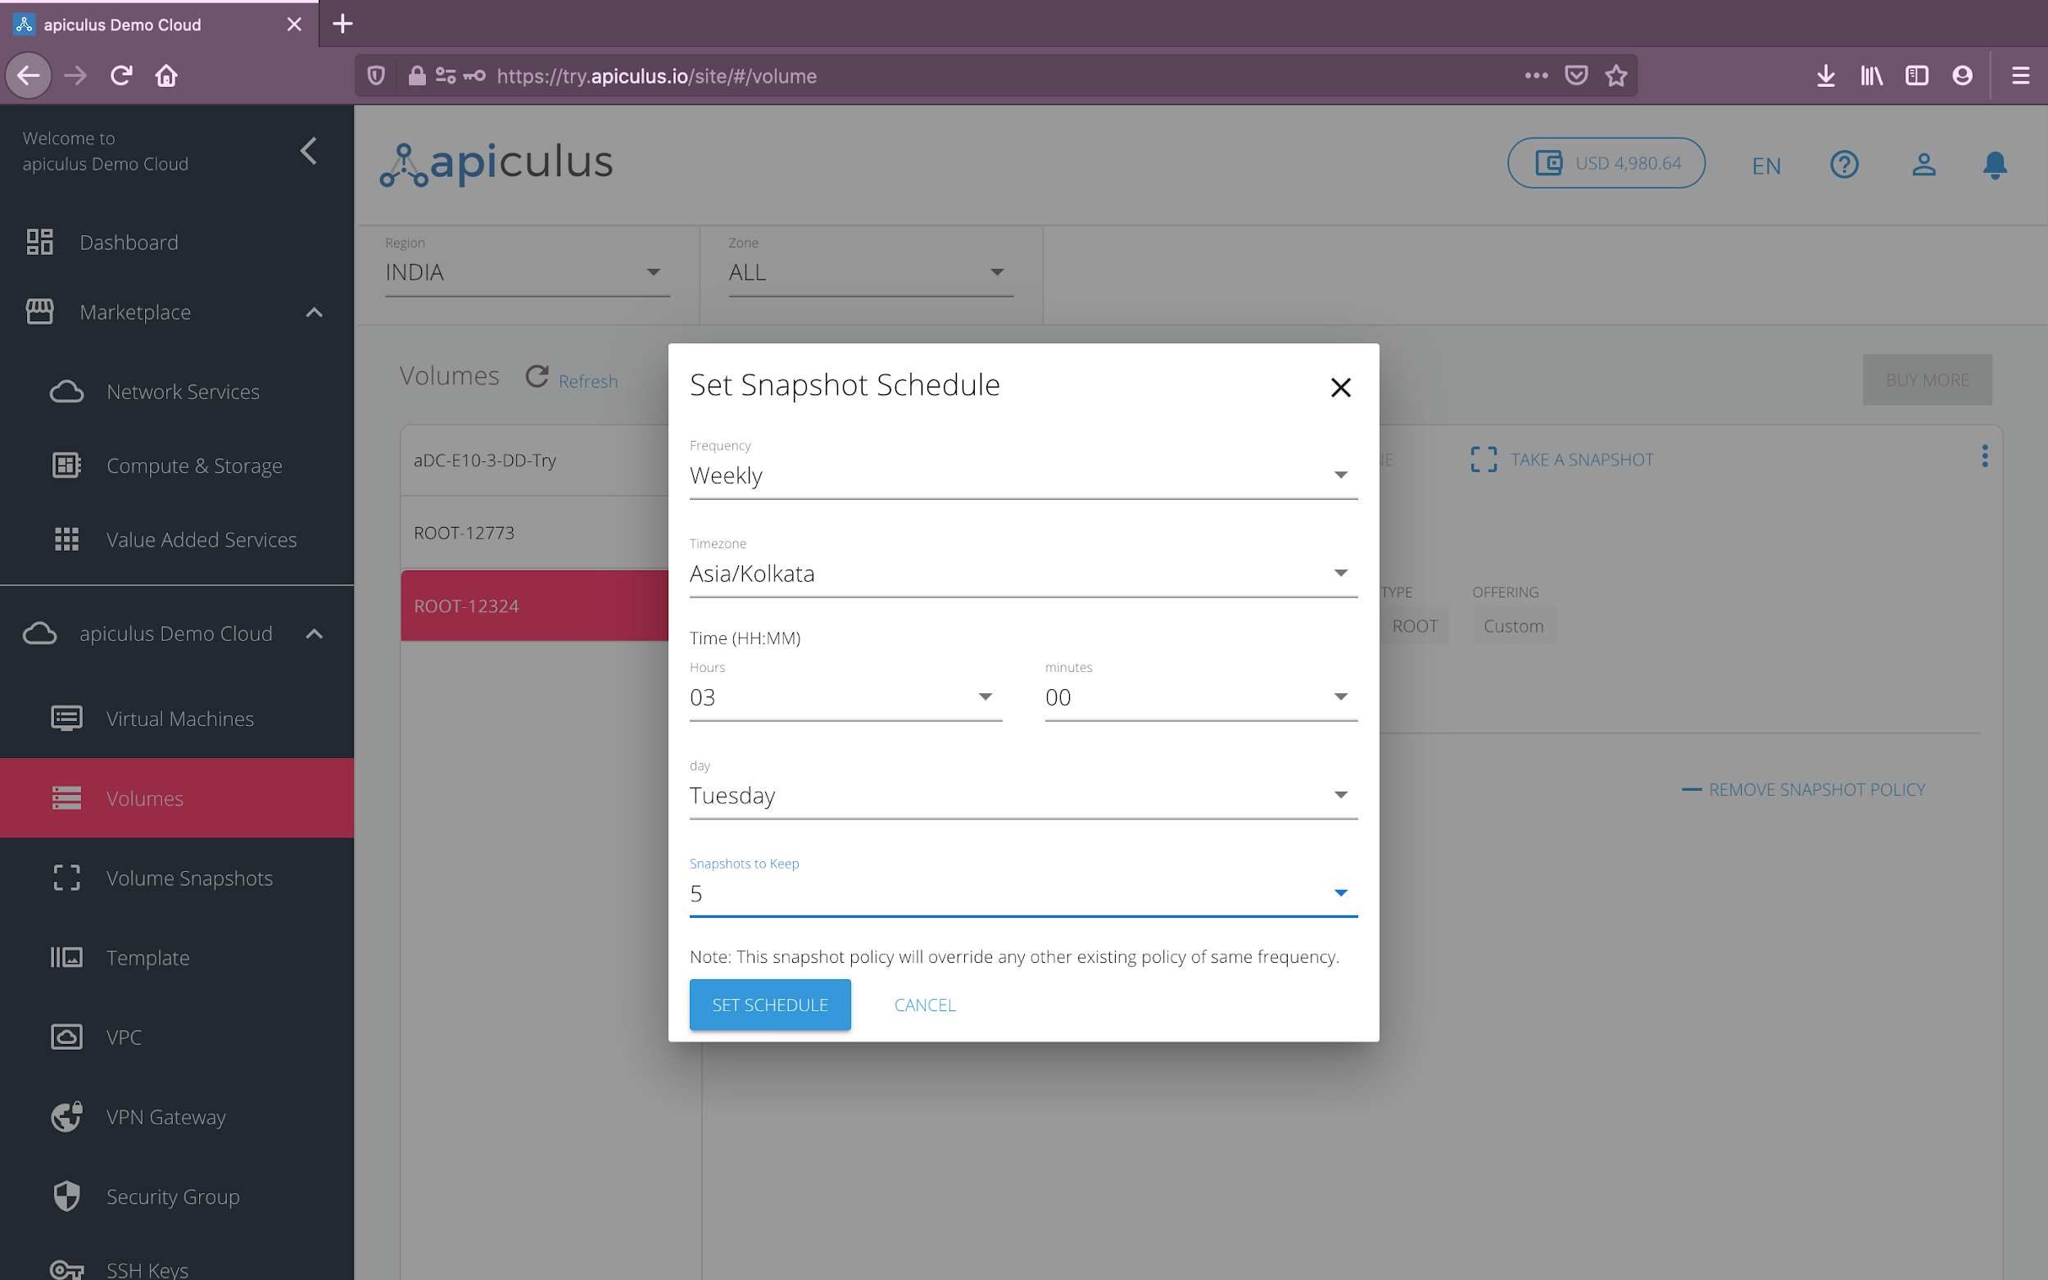

1. **Advanced Actions:** Volumes only support one advanced action, i.e., **deletion**. *Please note that deleting a volume will remove it entirely along with its subscription and is a non-reversible action.*

# 

# Snapshots

Volume snapshots are a powerful tool for data management and can be used as a basic backup system in conjunction with volume snapshot policies. Volume snapshots can be accessed from the **apiculus Cloud > Snapshots** section on the main navigation panel.

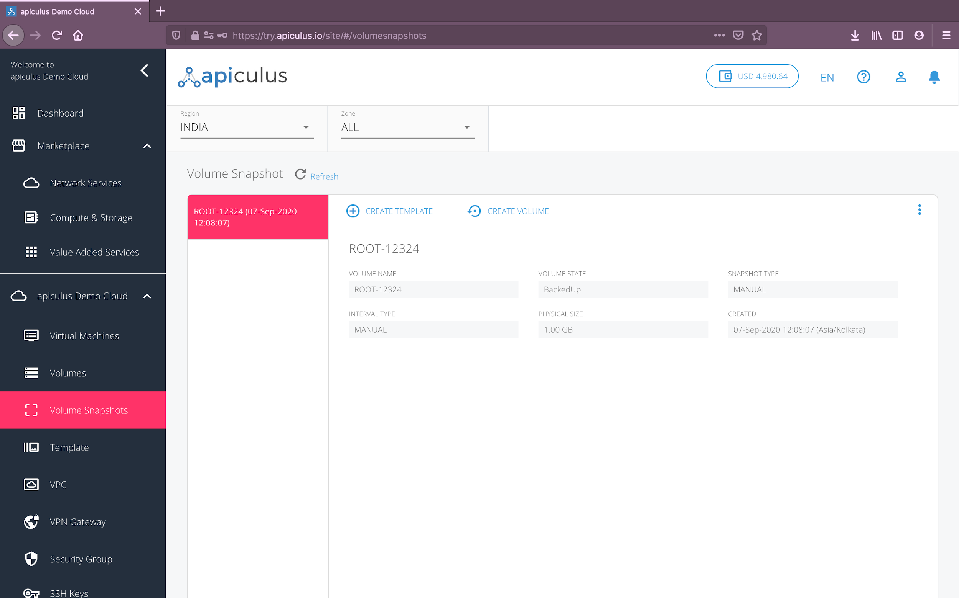

## Creating a Volume Snapshot

Volume snapshots can be created from a volume (root as well as addon) as an instant snapshot or as part of a snapshot schedule/policy. *Please note that volume snapshots may take up considerable storage space and you may be charged for snapshot storage.*

## 

## Snapshot Operations

apiculus Cloud allows essential operations on volume snapshots. These can be classified as informational, quick and advanced actions:

1. **Informational:** All the information relating to the volume snapshot is available and can be accessed by navigating to **apiculus Cloud > Snapshots** on the main navigation panel, and clicking on the desired snapshot from the list of volume snapshots. The information panel shows information about the snapshot, e.g., its size, backup status, associated volume etc.
2. **Quick Actions:** You can perform quick actions on all volume snapshots. These are the most common actions that are taken on volume snapshots and can be accessed from a ‘quick action toolbar’ on top of each volume snapshot’s details.
   1. **Create Template:** to create a template that can be used as a base image for creating new virtual machines.

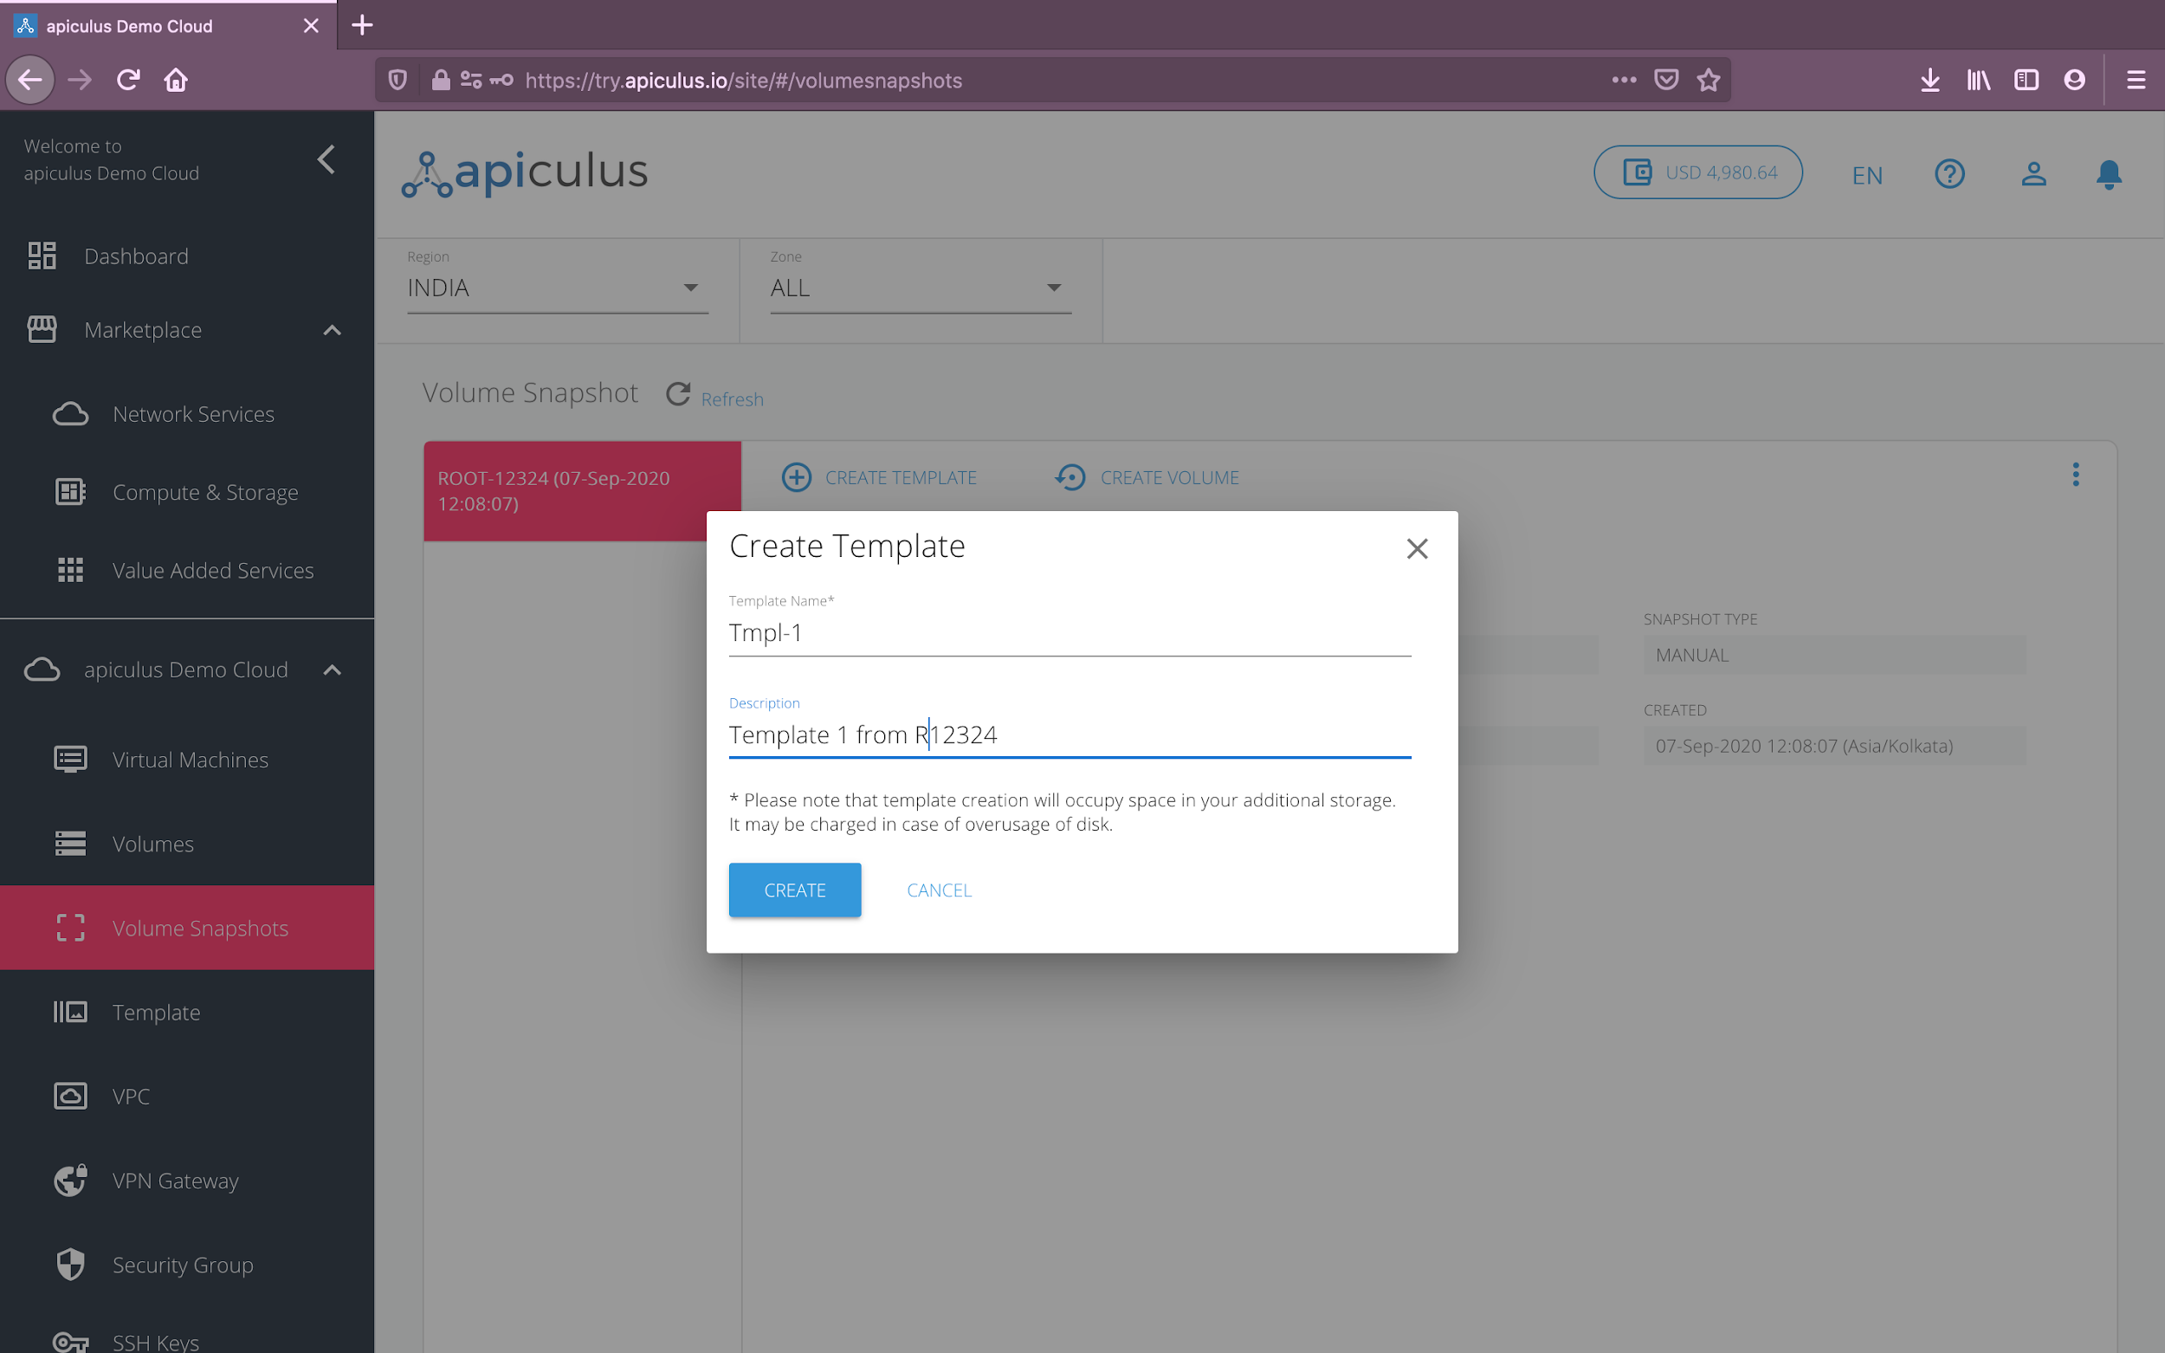

* 1. **Create Volume:** to create a new volume based on an existing volume via snapshots.

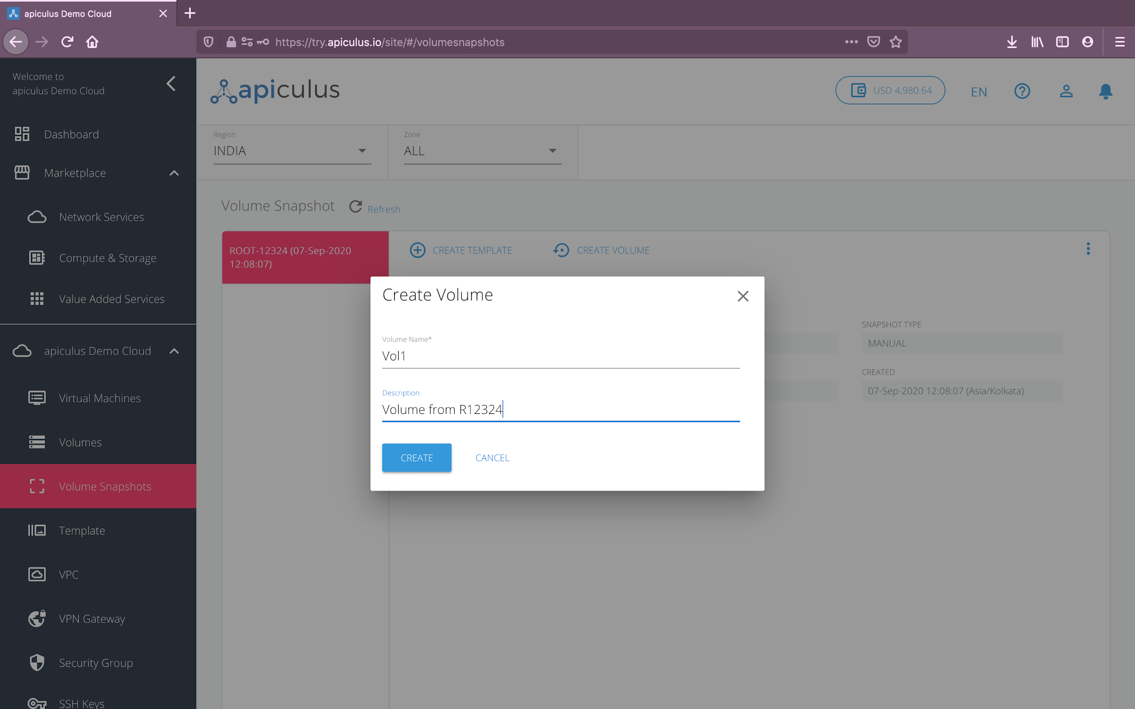

1. **Advanced Actions:** Volume snapshots only support one advanced action, i.e., **deletion**. *Please note that deleting a volume snapshot will remove it entirely and is a non-reversible action.*

# 

# Templates

Templates are a powerful tool for virtual machine setup and replication and can be used with the apiculus Autoscale service to set up highly efficient application stacks. Templates can be accessed from the **apiculus Cloud > Templates** section on the main navigation panel.

## Creating a Template

Templates can be created from a volume snapshot. *Please note that templates may take up considerable storage space and you may be charged for template storage.*

## Template Operations

apiculus Cloud allows essential operations on templates. These can be classified as informational, quick and advanced actions:

1. **Informational:** All the information relating to the template is available and can be accessed by navigating to **apiculus Cloud > Templates** on the main navigation panel, and clicking on the desired template from the list of templates. The information panel shows information about the template, e.g., its format, status, zone etc.
2. **Quick Actions:** You can perform quick actions on all templates. These are the most common actions that are taken on volume snapshots and can be accessed from the template’s quick action toolbar. For templates, the quick action bar provides the option to **create a new virtual machine** using the template.
3. **Advanced Actions:** Templates only support one advanced action, i.e., **deletion**. *Please note that deleting a template will remove it entirely and is a non-reversible action.*

# 

# Virtual Private Clouds

apiculus Cloud ships with an in-built powerful SDN framework called Virtual Private Cloud (or VPC). The VPC functionality can be used to configure advanced virtual networking, simulate private cloud environments, and also be used with VPN gateways to create secure connections to the VPC sites.

The detailed VPC creation and configuration steps are explained in [Creating and Configuring a Virtual Private Cloud](https://docs.google.com/document/u/0/d/1WcnMugrnQb-yD5iK_uhpPMJujrrN7cC8MRJvaSkyoLg/edit).

## Getting Started with a VPC

To get started with setting up a VPC, you need to first purchase a VPC Virtual Router (VR) from the apiculus Cloud Marketplace. A VPC VR is essentially a virtual machine that acts as a software-defined networking router which can be used to create subnets, access control policies etc. A VPC, by extension, is the actual virtual network architecture that is created behind the VR by setting up logical structures of tiers, load balancers, port forwarding etc.

A VPC Virtual Router can be purchased by following these steps:

1. Navigate to **Marketplace** > **Network Services**.
2. Choose the appropriate **region** and **zone** from the dropdown menu on top. *This is needed if there are multiple VPC zones available as part of the public cloud setup.*
3. Select a plan from the options listed under **VPC Virtual Routers**.
4. Alternatively, you can also navigate to the **apiculus Cloud > VPC** section on the main navigation panel, select the appropriate **region** and **zone**, and click on the **Buy More** button. This will list all the available options for VPC Virtual Routers.

Once you’ve chosen the desired plan, you’ll be asked for the following details to set up the VPC:

* A **name** for the VPC.
* The **super CIDR** for the internal IP allocation in a x.x.x.x/x format.
* If there are **promo/discount codes** available for this purchase, you’ll be shown those options.

Clicking on **Confirm Purchase** with the above information will provision the VPC Virtual Router in your account.

Please note that this might take up to 5-8 minutes. You may use the CloudConsole during this time, but it is advised that you do not refresh the browser window.

Once ready, you’ll be notified of this purchase on your email address on record. The newly created VPC can be accessed from **apiculus Cloud > VPC** on the main navigation panel.

To start using the virtual router as a VPC requires basic network configurations to be done. This section describes the steps for the same, and for adding virtual machines to the network.

## VPC Operations

apiculus Cloud allows a host of operations on virtual private clouds. These can be classified as informational, quick and advanced actions:

1. **Informational:** All the information relating to the VOC is available and can be accessed by navigating to **apiculus Cloud > VPC** on the main navigation panel, and clicking on the desired VPC from the list of VPCs.
   1. **Overview:** Shows information about the VPC, e.g., VR configuration, VR name etc.
   2. **Network Tiers:** Shows a list of configured subnets along with their details.
   3. **Public IPs:** Shows a list of all (default and purchased) public IP addresses in the VPC.
   4. **Access Control Lists:** Shows a list of all (default and configured) access control lists and rules in the VPC.
   5. **VPN Connections:** Shows a list of all VPN connections that are accessing the VPC.
2. **Quick Actions:** You can perform quick actions on all VPCs. These are the most common configuration actions that are taken on VPCs and can be accessed from the VPC’s quick action toolbar.
   1. **Add Network Tier:** To create subnets within the VPC.
   2. **Add Public IP:** To add public IPs for using as static NAT, port forwarding or load balancing.
   3. **Add VPN Connection:** To use your ISP-provided VPN connection as a site-to-site IPSec tunnel.
   4. **Add Access Control List:** To create and configure access control policies for the VPC.
3. **Advanced Actions:** Advanced actions on VPCs can be accessed by clicking on the three-dot ellipsis menu to the extreme right of the quick action toolbar.
   1. **Manage Autoscale:** This will navigate to the autoscale console for creating autoscale rules.
   2. **Enable Site to Site VPN:** To enable using a VPN gateway with the VPC.
   3. **Restart Router:** To restart the VPC virtual router.
   4. **Delete:** To delete the VPC. *Please note that deleting a VPC will remove it entirely along with its subscription and is a non-reversible action. Deleting a VPC also requires all its components (tiers, virtual machines, IP addresses) to be removed.*

## VPC Component Operations

Each VPC component has its own set of allowed operations for configuring advanced networking. The following operations are supported:

1. **Network Tier Operations:**
   1. **Add Virtual Machine:** Available/purchased virtual machines in VPC zones can be added to a tier.
   2. **Restart Network:** The subnet can be restarted without impacting the rest of the VPC.
   3. **Manage Access Control Lists:** ACLs can be replaced for a tier from the available ACLs.
   4. **View Attached Virtual Machines:** All virtual machines to the tier can be viewed.
   5. **Delete Network:** The network tier can be deleted entirely. *Please note that a tier needs to be empty, i.e., without any virtual machine, to be deleted.*
2. **Public IP Operations:**
   1. **Enable Remote Access VPN:** This option is available only for the VR’s default public IP and can be used to create a remote-to-site VPN connection to the VPC using an external VPN client.
   2. **Enable Static NAT:** This option allows using this public IP as a static translation to any of the contained virtual machines.
   3. **Add (and View) Port Forwarding Rule(s):** This option can be used to set up public-to-private port mappings for accessing virtual machines within the VPC.
   4. **Add (and View) Load Balancer Rule(s):** This option can be used to set up L4 load balancing for the public IP.
   5. **Release IP Address:** This will delete the IP address and remove all subscription records. This action is non-reversible.
3. **Access Control List Operations:**
   1. **Add Rule:** New ingress or egress rules can be added to the ACL.
   2. **Apply This List To:** ACLs can be applied to network tiers to replace existing ACLs.
   3. **Delete ACL:** This will remove the ACL and all associated rules.

# 

# VPN Gateways and Connections

The VPC feature on apiculus Cloud provides advanced networking capabilities for use with VPN gateways and connections over an IPSec tunnel. apiculus Cloud gives you the ability to create virtual private networks (VPN) to access virtual machines inside a VPC.

There are two types of VPN connections supported on apiculus Cloud:

1. **Remote Access VPN -** To connect securely from your home or office to your VPC on apiculus Cloud. This is used primarily when you’re using a dynamic IP to connect to the internet and a VPN connection can, therefore, not be pre-configured.
2. **Site-to-Site VPN -** To connect a private static network to your VPC on apiculus Cloud using an IPSec tunnel. Site-to-site gateways must be pre-configured on apiculus Cloud.

The underlying SDN on apiculus Cloud provides a L2TP-over-IPsec-based remote access VPN service to VPCs and guest virtual networks. Since each VPC has its own virtual router, VPNs are not shared across the networks.

*Please note that all VPN users in your account will get access to all VPNs created in your account.*

## Creating a VPN Gateway

Site-to-site VPN gateways can be configured from the **apiculus Cloud > VPN Gateways** section on the main navigation panel.

To create a VPN gateway, navigate to the VPN Gateways section and click on the **Add Gateway** button on the top-right. This will open up a dialog box with IPSec tunnel detail requirements. *Please note that you’ll need to obtain the gateway details from your ISP’s control panel or the primary firewall console.*

## Using VPN Connections with VPC

To use a site-to-site VPN connection into your VPC, you’ll need to first define a VPN gateway by following the steps in the above section. Once the gateway has been configured, follow these steps:

1. Navigate to **apiculus Cloud > VPC** from the main navigation panel and enter the VPC that you wish to connect to using the VPN.
2. In the VPC advanced action menu, click on the **Enable Site-to-Site VPN** option.
3. This will also enable the **Add VPN Connection** button in the VPC quick action toolbar. Click on the button and choose the VPN gateway that you want to use to connect to this VPC.

To test this configuration, you can ping any of the subnet IPs or the VR’s default IP from within your external private network.

## Using Remote Access VPN with VPC

To use a VPN client to connect to your VPC, follow these steps:

1. Navigate to **apiculus Cloud > VPC** from the main navigation panel and enter the VPC that you wish to connect to using your VPN client.
2. Click on the **Public IP** tab and from the default IP’s menu, click on the **Enable Remote Access VPN** option.
3. This will also enable the **Remote Access VPN** button for the VPC’s default IP. Click on the button to copy the pre-shared key (PSK) and the IP range from the dialog box to use in your VPN client.
4. Additionally, you’ll need to add VPN user credentials here.

To test this configuration, you can open the VPN client on your local system and try connecting to the VPC.

# Security Groups

Security groups are virtual firewall rules that can be set up for use in EC/flat networking. All accounts get a default empty security group which a new virtual machine can be associated with.

To manage security groups in your apiculus Cloud account, follow these steps:

1. Navigate to **apiculus Cloud > Security Groups** from the main navigation menu.
2. If you wish to add ingress or egress rules to the default security group, click on **Add Rule** in the security group details section on the right.
3. If you wish to add a new set of firewall rules, click on the **Add Security Group** button on the top-right. This will create a new security group for you to add more rules to.

It is recommended that you create your security groups and rules **before** starting to create virtual machines, as security groups can not be replaced once a virtual machine is created. It is good practice to plan security groups as a day 0 action.

*Please note that the default security group can not be deleted.*

# SSH Keys

apiculus Cloud allows you to create secure shell connections to virtual machines in your account by using SSH keys, in addition to using VM passwords. Passwords, due to their very nature, can easily be compromised. SSH keys, on the other hand, are encrypted signatures that function only when there’s a match between their public and private components.

## Managing SSH Keys

SSH keys can be managed from the **apiculus Cloud > SSH Keys** section on the main navigation panel. You can create SSH keys in any of the following ways:

1. New SSH key pairs can be generated from the **Generate Key Pair** button on the top-right. This will create a public-private key pair and download the private key on your system while keeping the public key in your apiculus Cloud account. You can then use the downloaded private key to connect to virtual machines that are associated with the corresponding public key.
2. Existing public keys on your system can be uploaded to your apiculus Cloud account by using the **Upload Key** button on the top-right. This assumes that you already have a key pair on your system and just uploads the contents of the public key (typically, a .pub file in your system’s SSH directory) to your apiculus Cloud account.

## Using Virtual Machines with SSH Keys

To use a virtual machine with an SSH key, it needs to be associated with a key first. This can be done in two ways:

1. While creating a new virtual machine, in the provisioning details form, choose any of the SSH options from the **Choose SSH Option** dropdown. This will let you:
   1. Generate a new key pair on the go.
   2. Upload a public key from your system.
   3. Choose an already added SSH key in your apiculus Cloud account.
2. For existing virtual machines, you can set or reset SSH key associations by going into the virtual machine’s advanced action menu and using the **Reset SSH Key** option. To use this option, the virtual machine needs to be stopped first. This option will only let you choose an SSH key already added to your apiculus Cloud account.